Group 7

ITWS 1100

March 21, 2022

RPIdorms

George is an incoming freshman that is looking to learn more about the dorms and student life at RPI. He has never been to campus and has no older siblings to give him any advice on what to bring. He came across RPIdorms.com while he was surfing the internet.

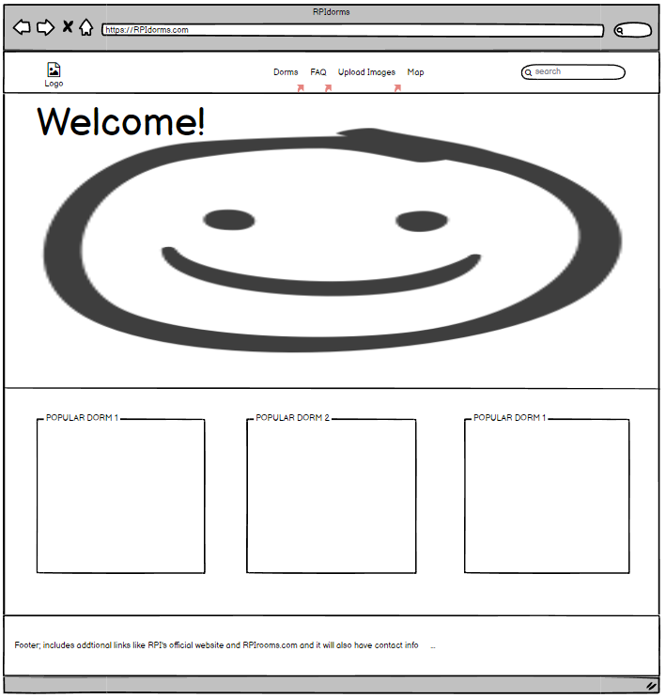

From the home page, he was able to get a general idea of what the website had to offer and learned about some of the popular dorms on campus. From the footer, he also found additional resources from other websites that he could look into later. Curious about the general layout of the campus, from the menu bar, he clicked on “Map” and was redirected to another page with a map of the campus.

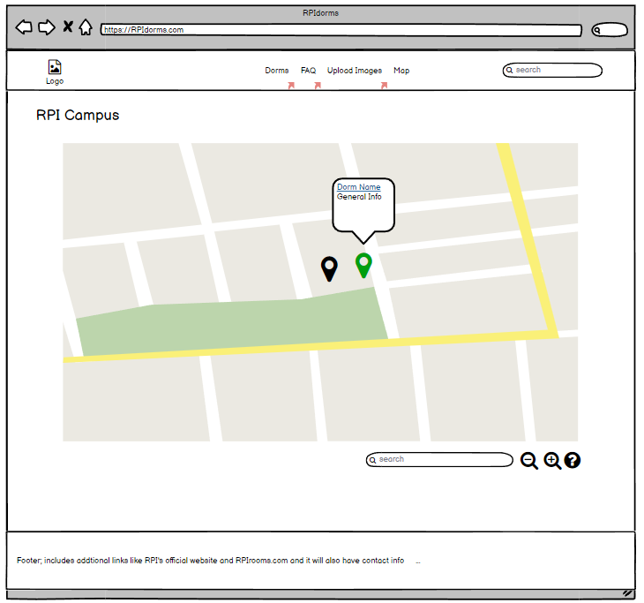

There are pins that can be selected. Once selected, it changes color to indicate it was clicked on and a popup appears with general information about the selected dorm. There is also a clickable link to the dorm if George wants to look into the dorm further. From the home page, he remembers Barton as one of the popular dorms and searches for it to navigate to it faster. After getting a general idea of the layout of the campus, he heads back to the menu bar to click on “Dorms”.

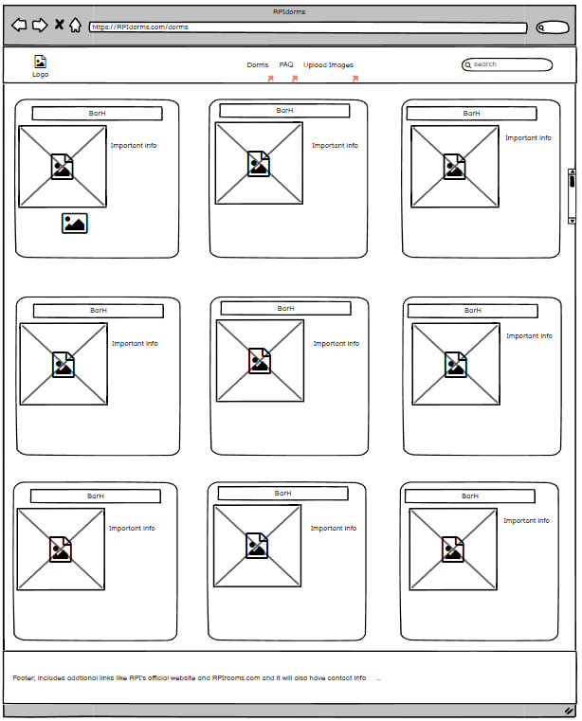

George scrolls through all of the dorms and skims through all of the information. He finds other dorms he is interested in and clicks onto one of them.

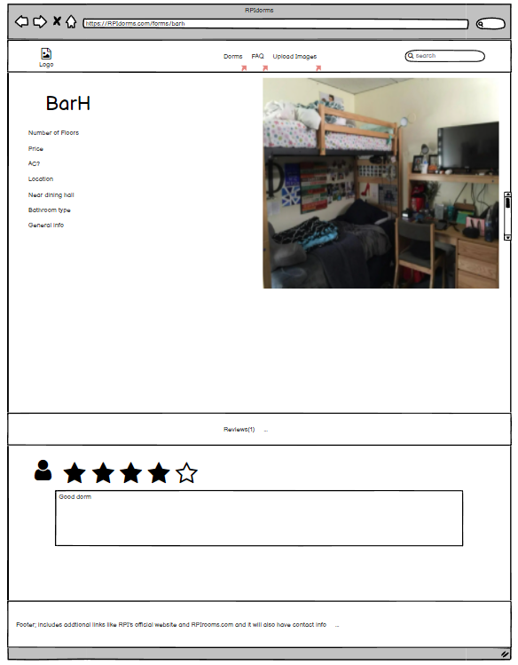

He gets to see more detailed information about the dorm he clicked on and on the bottom of the page, he can see reviews about the dorm left by other students that had visited the page prior to him. He finally comes to a conclusion on which dorm he wants to live in and moves to the “FAQ” page.

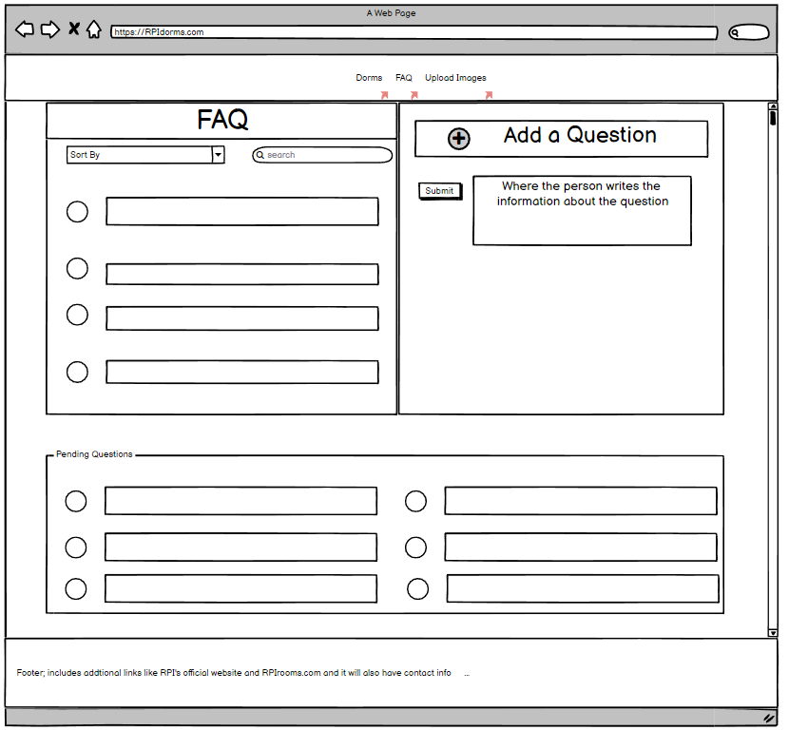

The screen is split into two sections. The left section holds all of the frequently asked questions about student life. George could sort the questions based on the specific dorm or search for keywords to find specific questions. The right section gives George the option to add his own questions and submit. One of the website’s administrators will be notified and answer as soon as possible. In the meantime, the question will be placed within the “Pending Questions” section to avoid any other users from asking the same question.

On the other hand, Sophia is a senior at RPI and has a lot of experience. She has taken part in a lot of clubs and even worked as an RA for a year. Unlike George, she decided to visit RPIdorms.com to leave her own review. From the home page, she clicked on the first popular dorm to get redirected to the specific dorm page and scrolled down to put her own review. Then she went to the “Dorms” page to see if there were any other dorms she could leave a review on. After she placed all her reviews, she went to the “Upload Images” page from the menu bar.

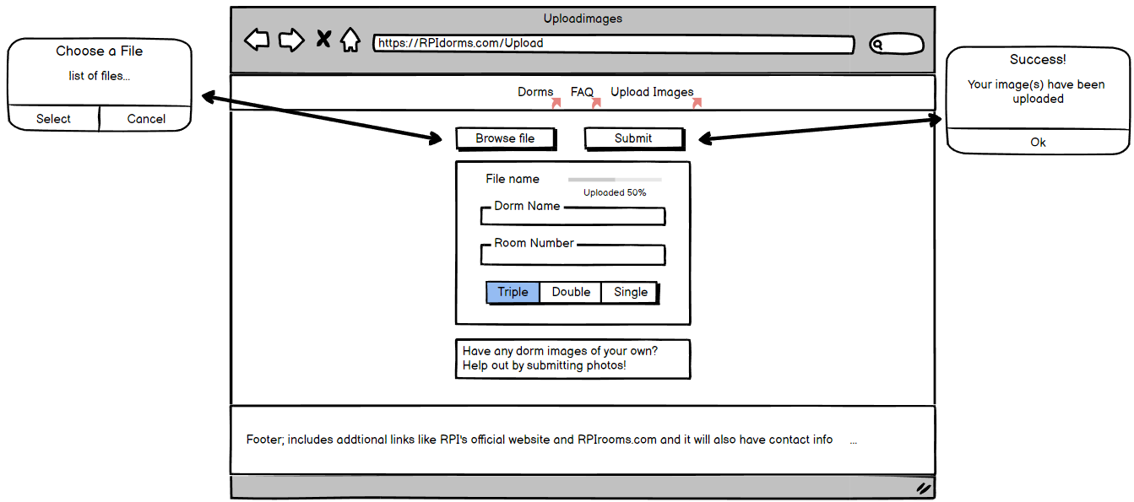

She clicked on the “Browse file” button which opened up a popup that allowed her to choose specific images to upload. While the images are uploading, she could fill out the necessary information about the image to help the administrators upload the images to the right dorm page. Once she finished filling it out, she hit the submit button and got an alert box telling her it was a success.